**INFO 1113 A 10**

**FINAL PROJECT**

**Professor: Abhijit Sen**

**Deadline of submission: 01 Dec 2021**

**This is a group assignment and each member plays an important role in completion.**

**United together.**

Members of the Group A:

|  |  |
| --- | --- |
| Name | Student Id |
| Gurdeep Singh | 100416973 |
| Navjeet Kaur | 100415874 |
| Harmanpreet Kaur | 100406918 |
| Jashandeep Singh Sidhu | 100411731 |

|  |
| --- |
| KPU email IDs (acc. to names arranged) |
| Gurdeep.singh8@email.kpu.ca |
| Navjeet.kaur8@email.kpu.ca |
| HarmanpreetKaur14@email.kpu.ca |
| Jashandeep.sidhu1@email.kpu.ca |

ASSIGNMENT 1 Website Links

|  |  |
| --- | --- |
| Name | Link |
| Gurdeep Singh | [Covid](https://sites.google.com/view/info-1113myproject1/home) |
| Navjeet Kaur | [Transit](https://sites.google.com/view/aboutheproject/home) |
| Harmanpreet Kaur | [Yoga](https://sites.google.com/view/info1113assignment/home?authuser=0) |
| Jashandeep Singh Sidhu | [Pay me](https://sites.google.com/view/jashanpayme) |

Table of contents

|  |
| --- |
| * Executive Summary |
| * Introduction |
| * Requirements |
| * Use case Diagram |
| * Use cases description |
| * Class Diagram |
| * Interface Prototype |
| * Relational database tables |
| * ER diagram |
| * Group Links |
| * URLs |
| * Project Experience |
| * Conclusion |
| * Works cited |

***\* CO-WIN*** * (name of application)

* ***Executive Summary***

This group assignment surrounds around an idea of spreading awareness and giving essential details of vaccination and getting the doses on particular time. As we all know, the pandemic of covid-19 has affected the human lives in very destructive way around the globe. Millions of people lost their lives due to this hard phase of pandemic. The doctors and scientists all over the world tried their best to find the solution to cope with the corona pandemic. Due to their hard work now, people are getting protection against the deadly pandemic. Not only the vaccine is 100% protection but we have to become more serious in order to fight with this. Our group assignment deals with that similar way of providing vaccination and giving the important details about different sorts of vaccination and mode of getting that. The name of the application clearly demonstrates the idea of win against corona i.e., CO – WIN.

Features of this application:

* Firstly, it deals with an idea of verifying the age eligibility so that proper and effective amount of vaccine can be given to all.
* Secondly, different types of vaccines and their location list is given to the customer so that he/she can choose the vaccine on their own.
* Security is the other good reason in this application under which the id proof like BC id or the passport id is collected for verifying purposes and mobile number or email is collected for notification purposes.
* The major point of this application is: It gives the details about the vaccine that how it is manufactured, their ingredients, type, no. of shots essential, possible side effects and especially their proper effective composition.
* The idea is concluded with the formation of online portal of the user and provide the health vaccination card to the customer and demand their honest review so that essential information is given to the next users.

By summing up, this application deals with the updation every day on their online portal which gives the good sight feature and the user will know about the time leap between both shots. Proper reference can be given to the other friends so that the individuals become conscious about the vaccines and their productivity.

* ***Introduction***

Our application is designed to regulate and manage the people’s timing available for getting 2 shots on proper time under specific conditions. Eradicating rumours and shine light on the necessity is the biggest specification of this application.

United we stand, divided we fall.

Let’s join the hands together and fight this evil pandemic.

GO CORONA GO

In response to the COVID-19 pandemic, the Co-win app is made which will aware people of rumours about covid-19 and its vaccine. This app’s specialty is to help people know about covid-19 and its vaccine. How people can protect themselves from this devasting disease. In its efforts to support the public health benefits people will start taking vaccines without any fear. This app will help people know from what this vaccine is made and what effects they might see after getting their dose. One part is also included in this application where a person will see what precautions he needs to take after taking the first dose. Another, step in this application is where a person can easily book his appointment online and choose the date and type of vaccinations of his own will. The person can also choose the walk-in option as per his choice. At last, the review option will be displayed. The user will be asked for a review that how was the users experience? Was the information the person gathered through this app useful or not

* ***Requirements***

***$ Functional***

**1. Welcome page function:** The welcome page will be represented in such a way that the user finds that fascinating on the first look and the name of the application will be shown with good transition and fade off effects.

**2. Age verification function:** The user will be requested to enter the age and then asked for the proof of date birth document which will verify the age eligibility and then proceed if not shows error.

**3. Selection of vaccine function:**  Under this the list of available vaccines will be given to user under which the proper list of ingredients included and other most essential information will be given and asked to select one from those and then proceed.

**4. Showing list of availability nearby function:** Under this location permission will be asked first to proceed and then check the available vaccination centre nearby.

**5. Selection of centre and mode of receive:** Under this the centre will be selected and mode of receive that is by appointment or by walk-in option will be given to the user.

**6. Creation of online portal:** Under this online id is created for the user under which their no. of dose and other essential information like days left for next vaccine will be given.

**$** ***Non-Functional***

**1. Email or SMS function:** Under this, when a person is successfully registered as a user of application then the vaccination certificate will be sent to the user.

**2. Permissions function:** Under this, various permissions will be asked from the user such as terms and condition apply verification, storage use and files access.

**3. Tutorial Function:** This is also another superb function under which a separate 5-minute tutorial will be given so that user can learn how to use the application properly.

**4. Security Function:** Maintaining the security and privacy about the details given will be secured under the high security non accessible folders except user under which special recognition function such as biometrics or passcode will be asked which was to be set by the user.

**USE CASE DIAGRAM**

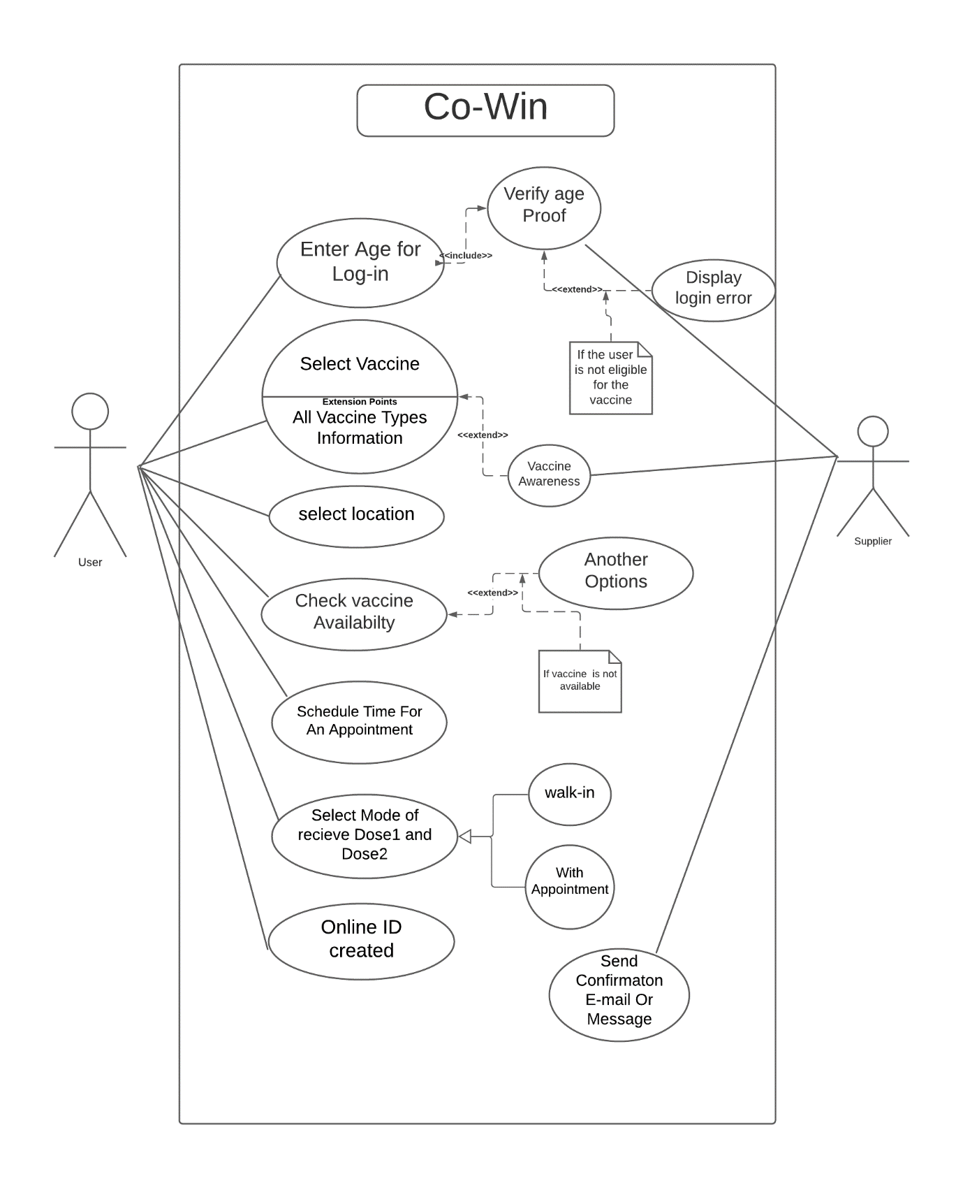

**USE CASES DESCRIPTION**

This application works in a simple dimensional detail. First of all, the application will show the welcome page under which the screen shows the name of application with sliding effects. Then the permission of storage, files and location will be accessed and the application proceeds further only when the user’s age is verified by the document of age proof. Then after this step the list of vaccines and its information about the ingredients, side effects, medication and area of getting the first and next dose with the days is given.

(Done admirably by Navjeet)

The details will be shown like this:

|  |  |  |  |  |  |  |
| --- | --- | --- | --- | --- | --- | --- |
| Name | Brand | Type | Shots | Ingredients | Effectiveness | Side effects |
| Pfizer | Comirnaty | MRNA | 2 | RNA, lipids and fats | 51 % male  49% female | Pain, redness and fever |
| Moderna | Moderna TX | MRNA | 2 or 3 | Salts and potassium chloride | 53% male  47% female | Headache and fevers. |
| AstraZeneca | AZD1222 | Vaxzervria | 2 or 3 | EDTA, ethanol, sodium chloride etc. | 52% male 48% female | Fever, dizziness and muscle pain. |
| Johnson & Johnson | JNJ-78436735 | Viral vector | 2 | L histidine, sucrose polysorbate etc. | Accumulative: 61%  For both sections. | Pain and fever. |

To find the nearest vaccine facility, the user must enter their address and vaccine type into the app; after selecting the location, there is an option to verify availability. There are two sections here: first, if the vaccine is not available in the selected location, it will advise the user to choose another location and show when the vaccine will be available there; second, if the vaccine is available in the selected location, it will direct the user to the next phase, which is to schedule an appointment. (Done admirably by Harman)

Then the mode of vaccine is selected under which the user has to select the mode that is according to their specification that is by walk-in and by appointment. Then the app responds according to the facility and the service of the vaccination centre. The time is scheduled and user go there and show details and has their vaccine shot. There is a great proverb by wise, “Precaution is better than cure”, the app also shows the medication that can be taken after getting vaccinated if the vaccine shows the side effects.

(Done admirably by Gurdeep)

The user has an online ID created during the application's first steps, which includes evidence of date of birth and other contact information (first name, last name, phone number). Once the user downloads a certificate from the download option that is offered on the app after getting the vaccine at a specified location with this online ID evidence, an automatic confirmation email and message will be sent to the registered mobile number and email. Finally, there would be recommendations and a comment box for user feedback.

(Done admirably by Jashan)

^ CLASS DIAGRAM ^

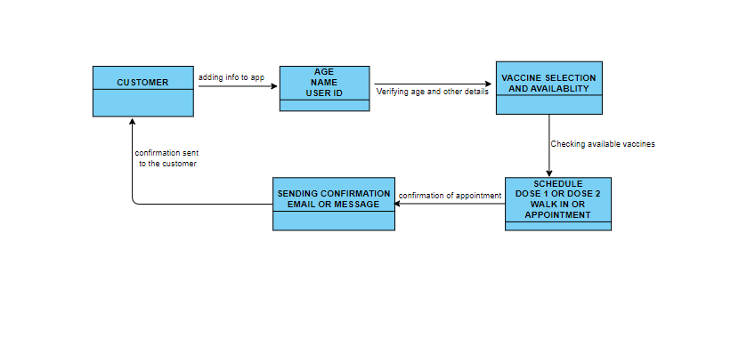

* Interface Prototypes *

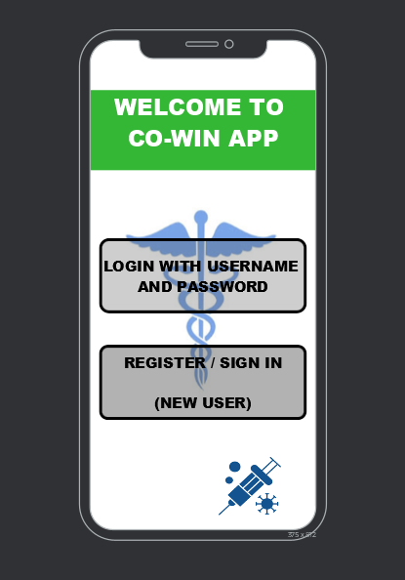

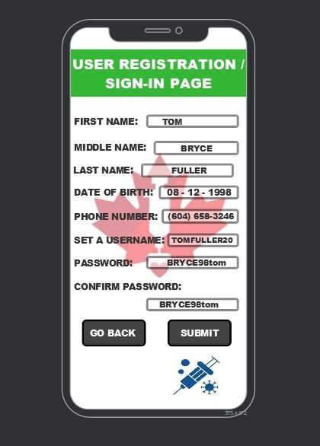

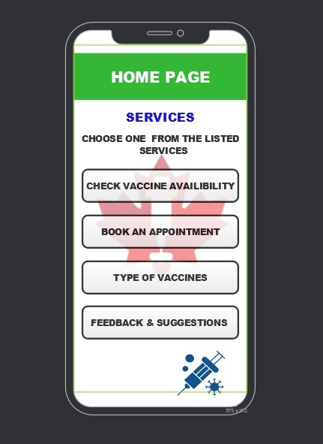

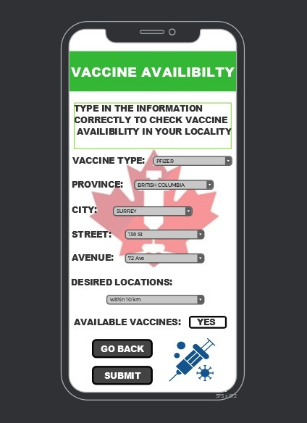

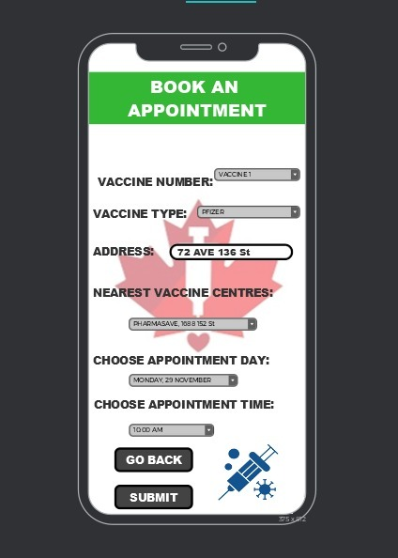

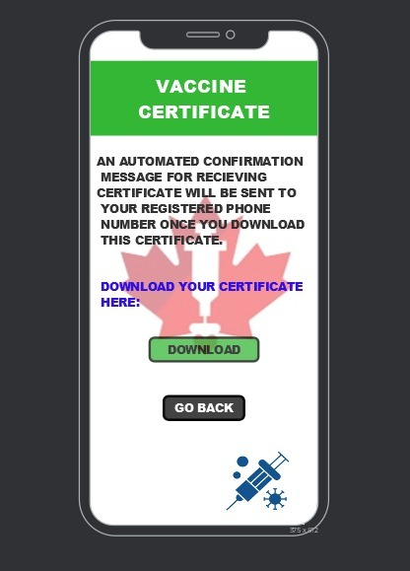

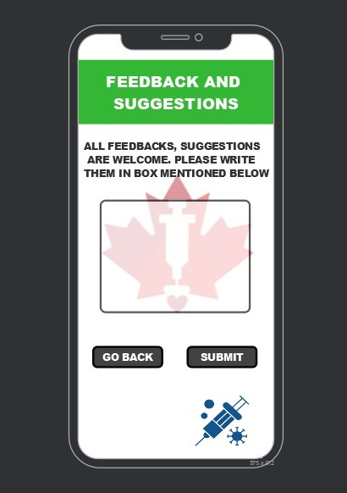

User Id created

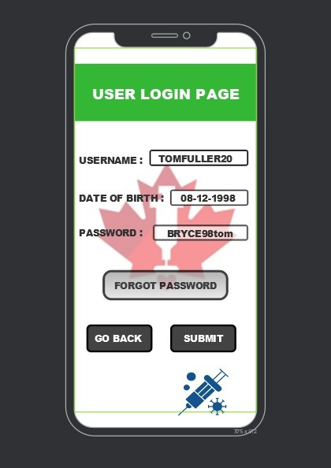

Relational data base tables

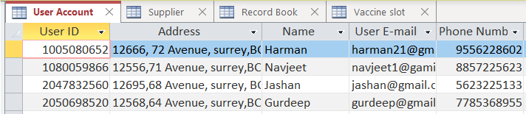

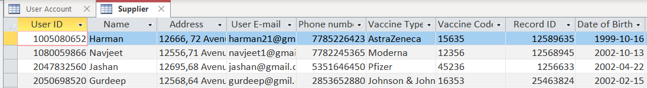

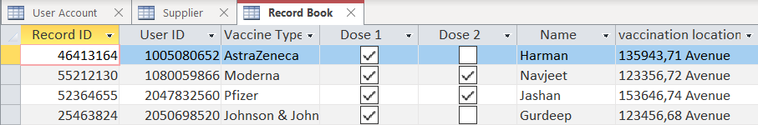

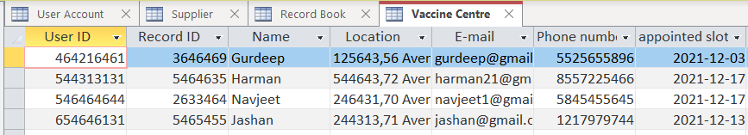

ER diagram

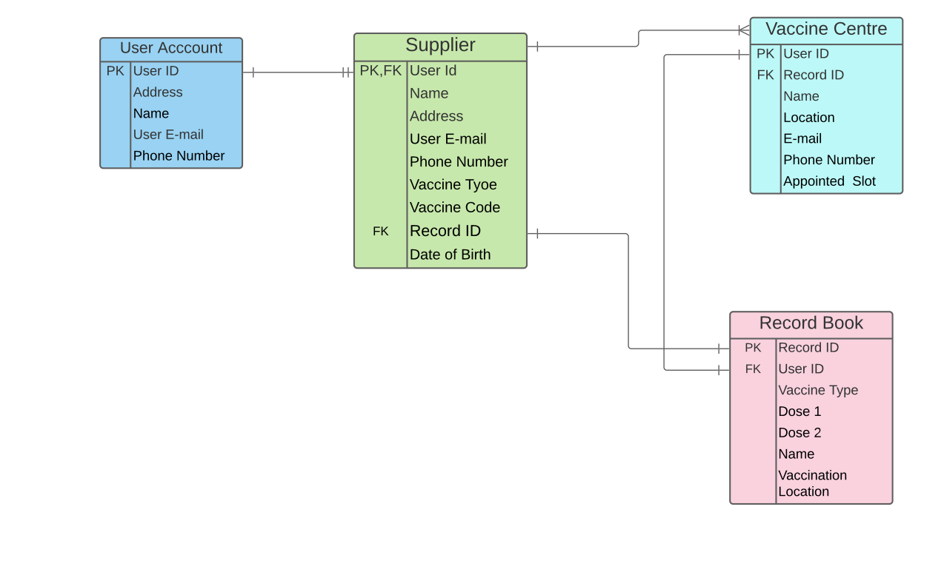

Group links

**# Trello link**

[**https://trello.com/b/Jry6psaW/info-1113-final-project**](https://trello.com/b/Jry6psaW/info-1113-final-project)

**# GitHub link**

[**https://github.com/Gurdeeps12/Info-1113-Final-Project**](https://github.com/Gurdeeps12/Info-1113-Final-Project)

**# Group Website link**

[**Info 1113 Group Website**](https://sites.google.com/d/1vjhWW2iTKdzZPA5Dmx8cGq0fj0YnU9A_/p/1YxRuhJ7KWV9vTj5XOBl9eP8fTFFpmPel/edit)

**# URLs of GitHub of each member of group**

* **Gurdeep Singh:**

[Gurdeeps12 · GitHub](https://github.com/Gurdeeps12)

* **Navjeet Kaur:**

[NavjeetKaur11 · GitHub](https://github.com/NavjeetKaur11)

* **Harmanpreet Kaur:**

[Harmanpreet12345 · GitHub](https://github.com/Harmanpreet12345)

* **Jashandeep Singh Sidhu:**

[jashanaug111 · GitHub](https://github.com/jashanaug111)

***PROJECT EXPERIENCE***

Our group was of 4 members Navjeet Kaur, Gurdeep Singh, Jashandeep Singh Sidhu, and Harmanpreet Kaur. At first, it was not easy for all of us to choose the project as everyone’s idea was unique in its own way but we decided to do a voting system by which we could easily choose one particular idea, and then everyone agreed to go with “GURDEEP’S “idea as nowadays everyone is scared from coronavirus and it is necessary for everyone to know how can we protect ourselves and others from this disease. Then it was hard for all of us to manage the work as all of us had different schedules but somehow everyone managed. All of us divided our work equally and every week we decided to attend zoom meetings and discuss our work. If any person had confused or was unable to understand the task all of us helped that person. Our team was very helpful, friendly, and cooperative. Everyone is hard working and managed to complete the given work on time. Doing project with these hardworking mates is the best experience.

**Conclusion**

*To conclude, Co-win app will help to aware people of fake rumours about the covid vaccine. People will gather information about vaccines and its precaution what to do after taking the vaccine. People need to know that vaccine is made to protect them and others from coronavirus. It will guide people to take vaccines and people can save their time by easily applying to get the covid-19 vaccine just by applying online. They can choose the vaccine of their choice, and this will help them to know about the vaccine as well as they will be asked to the listed precautions after taking the vaccine. The motive of this application is to aware people about coronavirus.*

*Works cited*

*Valacich, Joseph and Joey Jorge, Modern Systems Analysis and design, 8th Gen.,*

*Ed., Pearson, 2016*

[*GitHub*](http://www.github.com)

[*Trello*](http://www.trello.com)

[*Lucid charts*](http://www.lucidchart.com)